**Academic discussion**

**1. solution:** strategy to attract people to rural areas

**Respond:**

From my perspective, the comprehensive establishment of infrastructure is the priority to take into consideration, which is generally deficient in rural regions.

To further elaborate, a thorough infrastructure, encompassing various fields like transportation, education, entertainment, and healthcare, acts as the cornerstone to guarantee the welfare of local residents. Without it, a significant portion of rural population tends to migrate to urban centers for the sake of more advanced amenities.

Besides, the government should take measures to stimulate the financial prosperity of rural areas to provide more working opportunities.

To be more specific, the government can appeal more small and medium-sized enterprises to relocate to rural areas by offering them favorable policies, such as tax reductions and economic subsidies. Their arrival can create sufficient jobs, thereby enhancing the level of people’s income and local finance.

**2.Comparison:** grade on performance only or also effort

**Respond：**

From my perspective, evaluate students’ grades shall focus on students’ performance in their assignments and tests, as it might be the most objective and efficient approach to measure their progress in their studies.

To be more specific, excluding certain subjective factors like their effort, which are difficult to estimate, can make the grading process more consistent to truly reflect a student’s comprehension of the course. Additionally, an explicit assessment criterion plays an essential role in guaranteeing the fairness of grading process.

Moreover, such approach provides a precious chance to prepare them to deal with future challenges in their careers, since in many real-world scenarios, only the ultimate outcome matters.

In other words, a supervisor typically assesses employee’s work solely based on the quality of the assignment, without considering excuses like efforts. Students must get themselves accustomed to the crucial reality in advance to live up to real-world expectations, thereby enhancing their competitive edges. (153 words)

If Efforts:

Motivation and growth daily; holistic development/skills;

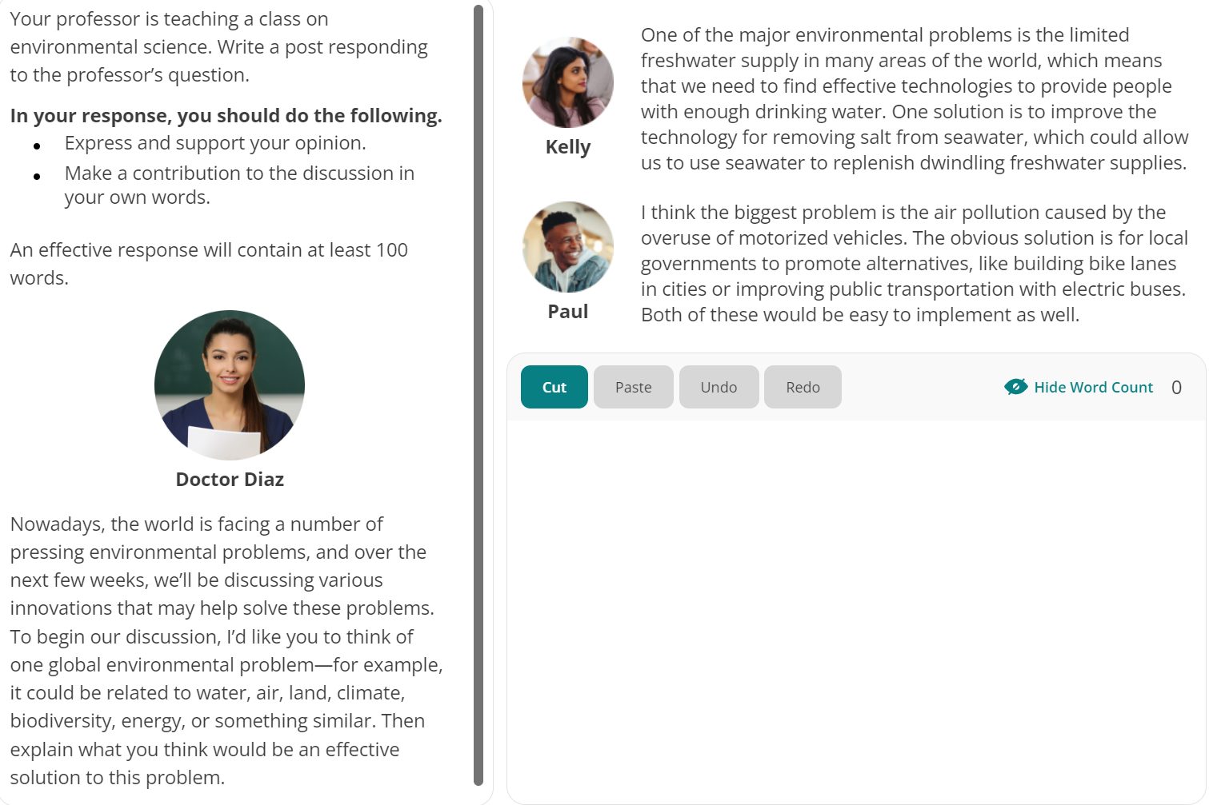**3.solution**: environmental problems and solutions

**Respond:**

From my perspective, addressing climate change should be our foremost priority regarding environmental problems, given the critical consequence it has generated to the ecosystem.

To elaborate, climate change, driven primarily by human activities such as the combustion of fossil fuels and the extravagant use of vehicles, has caused profound consequences, encompassing increasing the global temperature, rising sea-level and deteriorating ecosystem health.

Addressing climate problems requires a comprehensive and concentric effort from the government, industries and individuals. Specifically, under the strict regulation and criterion implementing by the government on industries, not only can manufacturer adopt cleaner technologies, but also they will have incentive to invest more sustainable and renewable energy sources like solar and wind.

Moreover, fostering the awareness of climate changes and its impacts through widespread dissemination and education is crucial for reducing the emission of pollutant yielded in daily life. Only through consistent cooperation and thorough strategies can we alleviate climate change and pave the way to a more sustainable future.

Other:

Reduce energy consumption and contamination emission; eco-friendly; technological innovation; carbon capture and storage; advanced batteries

**4.Evaluation:** a gap year or not

**Respond:**

From my perspective, taking a gap year will be of great benefit for students, since it’s a precious chance for them to harvest holistic development.

To elaborate, not only can a gap year provide students with sufficient time to consolidate the academic knowledge they acquire from high-paced curriculums, but also they would foster their communication abilities through engaging with others during their travels or work experiences.

Moreover, a gap year will better prepare students for their future career. To be more specific, a gap year for researching in laboratories or internship in enterprises will enrich their resumes, therefore increasing their competitive edge. additionally, practical experience during the gap year will expose students to deal with real-world scenarios instead of theoretical imagination based on their biased experience.

Admittedly, concerns may arise regarding the postponement of graduation and the potential financial burdens associated with a gap year. Ironically, from a long-term perspective, such cost may be peripheral compared to the life-long benefit you obtain .

**5.Comparison：**green spaces or infrastructure

**Respond:**

From my perspective, utilizing available areas for other significant purposes rather than green lands would be a more favorable choice, since the limited land can create more benefits for the well-being of inhabitants in this way.

To be more specific, it would be highly beneficial to construct essential infrastructure encompassing hospitals, shopping centers, and schools on these lands. These constructions are the foremost cornerstone to guarantee the high life-quality of local residents. For example, it will be more convenient for people to get comprehensive medicine treatment with a hospital nearby.

Moreover, using those land to establishing banks or small to medium-sized enterprises will be of great significant for financial prosperity of local region.

To elaborate further, with these enterprises, not only can the government alleviate the financial burden regarding maintaining the healthy function of the cities, but also people will get more employment opportunities, and thereby enhancing their average revenues. Those green lands and parks can be built at suburbs, providing citizens a place to entertain during their leisure time.

**6. Evaluation:** training employees or not

**Respond:**

From my perspective, complementing employee training is a favorable and beneficial investment for an enterprise, since it’s an efficient approach to maintain the competitive edge of the company.

To be more specific, through consistent training, not only can employees acquire new knowledges and skills, therefore enhancing their personal capacities, but also it would guarantee a company to keep pace with commercial trends, thereby increasing productivity and fostering creativity .

Besides, employee training serves as an effective strategy for attracting more talents to apply for positions within the company.

To elaborate further, Companies that prioritize employee development create an attractive work environment. Those high-education individuals prefer to select companies with prominent employee morale and job satisfaction.

7.**Evaluation:** use educational computer game or not

Respond:

From my perspective, utilizing computer games as a method to educate children might not be a favorable choice, as its educational effect may not meet our expectation, even potentially hindering the holistic development of students.

To be more specific, the knowledge children acquire might be superficial, as this kind of educational method promotes passive consumption, rather than active thinking and exploration. Moreover, it may even cause extravagant reliance on modern technology of children, thereby impairing their motivation to solve problems independently.

Besides, excessive exposure to computers will result in some health issues. To elaborate further, children are fairly easy to obsessed to computer games, which prolongs their exposure to screen radiation, increasing the risk of vision problems, including shortsightedness, eye strain and fatigue. On the other hand, playing computer games often involves a sedentary lifestyle. Deficient physical exercise can lead to various health issues such as obesity and muscle weakness.

8**.evaluation**: more leisure time or not

**Respond:**

From my perspective, I totally believe that people will enjoy more leisure time than nowadays, thanks to the rapid advancement of technology.

To be more specific, with the evolvement of modern technology, particularly the maturation of artificial intelligence, more individuals will be liberated from repetitive labors, enabling them to allocate their time to more lucrative and fulfilling business to achieve both fortune and well-being. Moreover, with the assistance of AI, the productivity and efficiency of fundamental manufacturing will boost undoubtedly.

Besides, with the accumulation of financial base, not only can people have more freedom to select their professions, but the government will attach more importance to the legitimate labor rights.

In another word, the government could alleviate their economic burden to sustain the function of the country, and therefore give the priority to the legal rights of residents to maintain the stability of the country. One practical strategy to fulfill this is the implementation of more favorable laws designed to preserve the labor rights of employees.

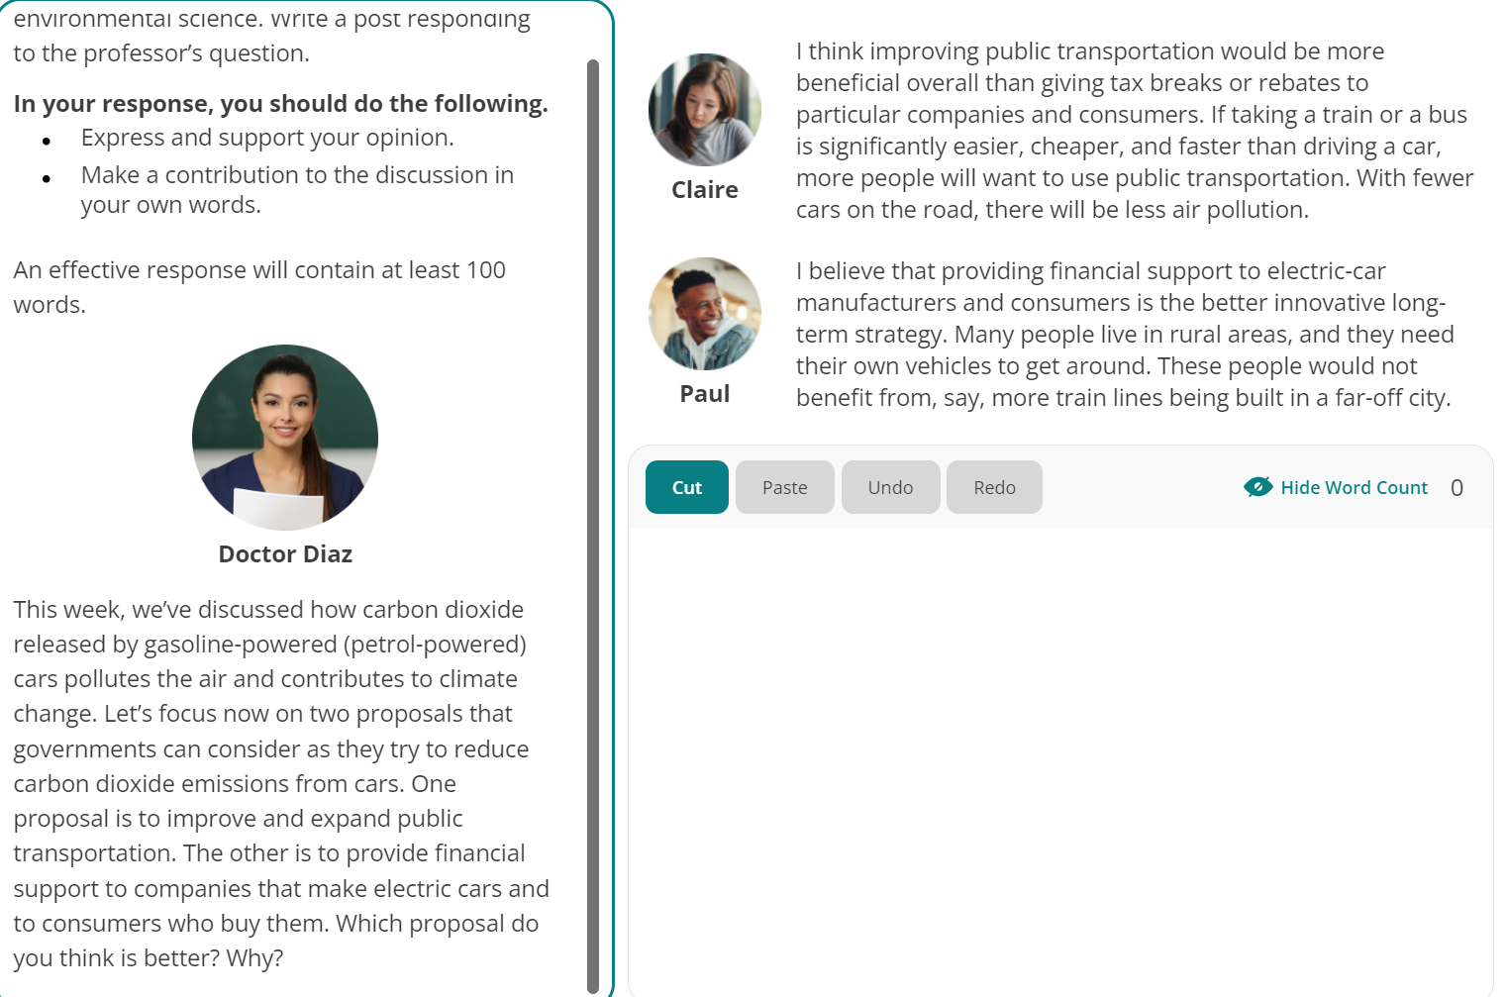9.**comparison**: method to lower carbon dioxide

**Respond:**

From my perspective, providing more financial support to enhance the utilization rate of electric cars would be a more favorable strategy regarding decreasing the emission of carbon dioxide.

First off, it’s highly acknowledged that the extravagant combustion of fossil fuels in traditional cars is one of the predominant source of carbon dioxide, inducing numerous environment problems like greenhouse effects. However, with the wide-spread use of electric cars, not only can people maintain the convenience of private transportation, but also less contamination will be release from conventional energy sources.

Moreover, with the support of both governments and consumers, enterprises will gain the incentive to pursue more eco-friendly technological innovations. To elaborate further, by implementing favorable policies, such as tax reduction and financial subsidies, more company will be appealed to invest in renewable energy like solar and wind power. Only through the concentric cooperation of governments, businesses, and consumers can we alleviate the emission of carbon dioxide and pave the way to a more sustainable future.

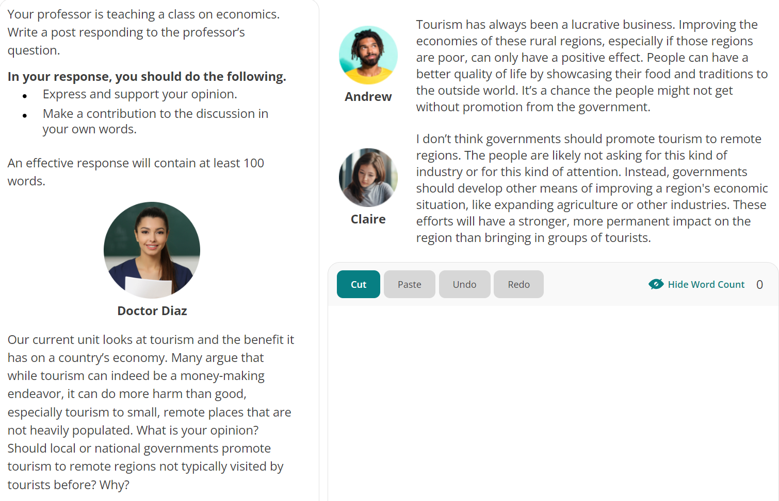10.**evaluation**: encourage tourism in remote areas or not

**Respond:**

From my perspective, utilizing tourism as a method to foster the development of remote regions might not be a favorable strategy, as the ultimate outcome will not be equivalent to the income.

To be more specific, the latent reasons for the poverty of remote areas are various, encompassing the poor transportation, the deficiency of nature resources, and the remote location. All these factors should be taken into consideration when the government enacts policies regarding the well-being of local residents.

Besides, the government should better formulate policies depending on the indigenous situation to fulfill the productivity and efficiency.

To elaborate further, governments should allocate more strength to improve the infrastructure of these regions, such as transportation and healthcare to guarantee the fundamental of local welfare. Moreover, more favorable financial policies should be provided to appeal more small and medium-size enterprises to relocate to these regions, such as tax reduction and economic subsidies. With the involvement of these companies, not only can residents get more employee opportunities, but also governments will alleviate the financial burden, and thereby have more energy to explore other approaches to achieve economic advancement.

11.solution: how to address housing shortage

Respond:

Refer to the first: strategy to attract people to rural areas

I agree with …. Viewpoint that. In addition, from my perspective, ……

12.comparison: the best way to assess teachers’ work

Respond:

From my perspective, estimating teachers’ performance based on their students’ scores might be a more favorable choice, given its efficiency and effectiveness in making evaluation.

To be more specific, there’s no denying that the priority of teachers’ work is to impart academic knowledges to students, and thereby consolidate and broaden their comprehensive understanding of their study. Therefore, the grades students attain are the most direct and conspicuous measure of whether teachers have completely dedicated themselves to fulfill his obligation.

Admittedly, both the feedback from students and more-experienced educators to teachers should also be taken into consideration. Nevertheless, it cannot be prioritized, since it’s inherently a subjective assessment. Individual relationship between teachers and students may have a substantial impact on the final outcomes. Thus, establishing an explicit and consistent criterion regarding teachers’ evaluation to guarantee the equality and accuracy is indispensable.

13**.evaluation:** whether should students spend time on field trips

**Respond:**

From my perspective, enabling students to participate in field trips might be a more favorable choice, since it’s significantly beneficial for the holistic development of students.

To be more specific, it’s highly acknowledged that the comprehensive development of students should not be confined to just academic study. Through engaging in these field trips to museums or historical buildings, not only can students broaden their perspective and horizon towards the world, but it could also stimulate their passion to explore more field regarding their subjects spontaneously.

Besides, taking field trips is a precious opportunity for students to alleviate their stresses and strains. Admittedly, students nowadays are generally over occupied by heavy study assignment. Thus, having a leisure time to take a breath while acquiring something new might inspire students to be more creative and vigorous.

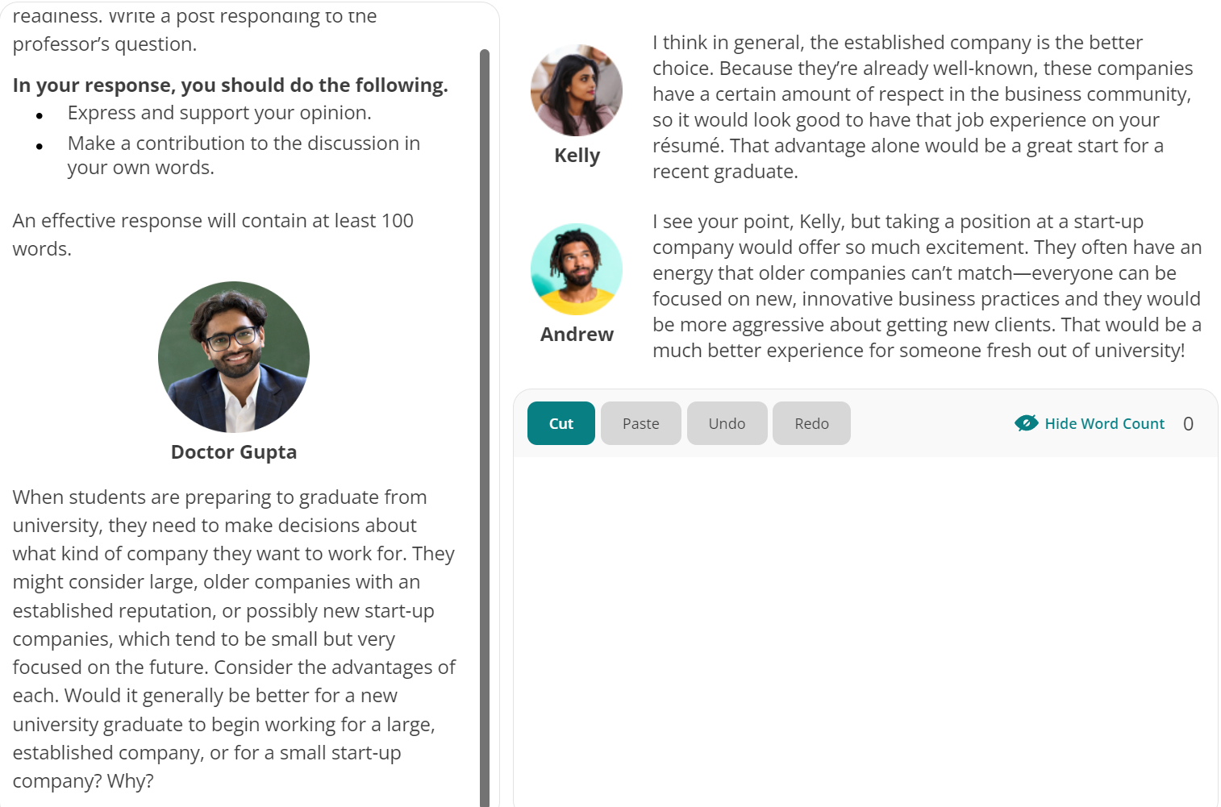14.comparison: a large company or a new

Respond:

From my perspective, selecting a large prestigious enterprise might be a more favorable choice, as it will guarantee the stability and high income of your initial job.

To be more specific, there’s no denying that large-scale companies have accumulated substantial financial resources and extensive experience, enabling them to attain the capacity to encounter economic depression, and thereby ensure the stability for the employees. Moreover, those established companies have formed a mature employee system, providing competitive salaries and attractive subsidies to appeal top talents.

Besides, large companies will establish a more conducive environment for the holistic development of their employees. Not only can those companies offer more comprehensive job training to their employees, allowing them to acquire valuable skills, but also individuals can gain the precious chance to broaden their perspective on a larger stage.

Admittedly, we cannot neglect the potential of some start-up companies, but it’s equally crucial to weight the associated risks and stability factors before making a decision.

15.solution: maintain employees

Respond:

1. job training to enhance competitiveness edge

2. employee morale and job satisfaction by providing higher salary and comprehensive subsidies

16.evaluation: journal writing is worthwhile?

Respond：

From my perspective, utilizing journal writing as an educational approach is undoubtedly a favorable choice, as it’s significantly beneficial for the holistic development of students.

To be more specific, through journal writing, not only can students obtain a precious chance to foster their capacity of self-expression, but also it encourages self-reflection and critical thinking. The self-awareness can lead to a comprehensive understanding of their subjects, and therefore consolidate their academic knowledges.

Besides, journal writing serves as an efficient method for teachers to get insight into the effect of their education, since the writing serves as a direct feedback， indicating whether students have completely grasped the subject issue. Depending on the feedback, educators could adjust their teaching strategies instantly to fulfill the efficiency and accuracy of education delivery.

17.evaluation：optional attendance of courses?



Respond:

From my perspective, utilizing optional attendance as an educational strategy might not be a favorable choice, since the involvement of classes play a crucial role in the holistic development of students.

To be more specific, through the engagement of students in class, peers can establish a robust connection with their professors and classmates. Whenever students have any questions regarding their subjects, it’s convenient and efficient for them to collaborate with their classmates or seek for the assistance of their teachers, and therefore broaden and consolidate their academic knowledges.

Besides, implementing compulsory attendance serves as an integral approach to prepare students for their future career. In real-world professional scenarios, your supervisors will take your regular attendance and active participation as a fundamental criterion to evaluate your performance. Mandatory class attendance prepares students for these expectations, imparting them a sense of responsibility, discipline and commitment—qualities pivotal in their career path.

18.evaluation：whether should children work part-time

Respond:

From my perspective, encouraging children to take a part-time job for their future career might not be a favorable choice, since it might potentially impair the holistic development of children.

To be more specific, during the period of their childhood, what children’s responsibility could never be served as employees, but enjoying the precious golden time. Through the natural process of their growth, children’s capacity of cognition and comprehension will nurture and foster, and thereby acquire the fundamental competences, such as problem-solving communication and independence, which are indispensable for their future career.

Besides, I wholeheartedly agree with Andrew’s statement emphasizing the importance of dedicating time to study rather than engaging in part-time employment.

Additionally, kids should prioritize their study to broaden and consolidate their academic knowledge to enhance their competitiveness edge in the future job market. Moreover, Mandatory class attendance can also impart them a sense of responsibility, discipline and commitment—qualities pivotal in their career path.

19.evaluation：ask young to teach senior

Respond:

From my perspective, encouraging junior employees to mentor senior coworkers could be a favorable choice, serving as an impetus to enhance the competitive edge of enterprises.

To be more specific, admittedly younger employees might be deficient in experience, but they are prone to be more vigorous and creative. Through imparting knowledges from the junior, not only can the senior coworkers keep pace wilth modern information, but also it’s a stimulus for them to generate more brainstorming, thereby increasing the competitiveness of their company with more creative innovations.

Besides, in the long term, it’s also an efficient strategy to foster the employee morale and attract more top talents, as it indicates the basic working atmosphere of a company. Qualified individuals are more inclined to select those company appreciating the value of new employees.

20.comparison: offer money or offer training

Respond:

Admittedly, alleviate the temporary crisis of their livelihood

Aggravate the financial burden of governments, and doesn’t solve inherent and fundamental problems

Provides them chance to acquire up-to-date skills, foster their capacity and competitiveness in the job market and addressing unemployment and poverty, guarantee financial stability and the welfare of people

21**.evaluation**：require teachers to take courses

**Respond：**

Favorable choice; instill teachers with updated educational method, technologies, integrate those approaches in their class, stimulate teachers to maintain their incentive towards education; continuous learning enhance the qualities of education they provide — holistic development of students

Admittedly, they are over-occupied with……, but ironically, Teachers nowadays excessively emphasize their own scientific researches, neglect the importance of fundamental education

22.**evaluation**: whether should family spend time together

Respond:

From my perspective, encouraging family members to engage in collective works serves as a favorable strategy to reinforce family bonds, as it might be the most efficient approach to unite family members to foster a sense of family morale.

To be more specific, engaging in enjoyable and creative activities together provides family members a precious chance to cooperate with each other to pursue a certain goal or complete a common assignment. For example, participating in activities such as hiking not only allows them to enjoy picturesque sceneries, but also provides a platform for mutual assistance and cooperation. Through the shared endeavor and mutual communication, they create a robust sense of identity and belonging within the family.

Admittedly, such collective efforts might lead to occasional friction within the family. Nevertheless, it’s also an inevitable barrier they need to encounter and resolve together. Family members must learn how to appreciate the diversity and respect other’s value, rather than avoiding from encountering collision.

23.evaluation: whether will cinema disappear

Respond：

From my perspective, I wholeheartedly agree with Paul that the existence of cinema will remain immutable in the future, as cinema provides a unique platform for people to share a collective experience.

To further elaborate, cinemas offer a peculiar social experience that streaming services cannot substitute. Cinemas not only serve as ideal places for people to hang out for entertainment, but also provide precious opportunities to reinforce the connection between individuals. For example, couples are prone to spend a date night watching a romantic film together on a big screen, rather than staying at home to watch TV.

Admittedly, films nowadays are fairly accessible and convenient to be watched on television. Nevertheless, the cinematic experience from big screens can not be replicated. Watching movies in cinemas involves superior visual scenes and eminent acoustic effects, offering audiences an unparalleled audio-visual experience.

24**.opinion:** the preponderance of museum in a city

Respond:

1. educational enrichment

provide a platform for residents to explore and engage in different kinds of arts, inspire their curiosity and creativity, foster an atmosphere of lifelong learning, enhancing their aesthetic capacity of appreciation

2. an efficient strategy to attract tourists, enhancing indigenous tourism and economy, alleviate financial burden of governments, bring cultural benefits(a method to disseminate their city history and boost popularity)

25**.comaprison:** communication skills or technical background

**Respond:**excellent communication skills might be more a competitive capacity for a leader.

1. team building and establish positive employment morale, inspire motivate and lead the team to pursue a collective goal, cooperation, nurture team cohesion and enhance productivity and efficiency.

2. an indispensable quality to communicate with external enterprises. Deal with / negotiate with clients, partners, and the public. Attract investment and maintain the reputation and prestige of companies,

3. attract top talents, boost the competitiveness edge

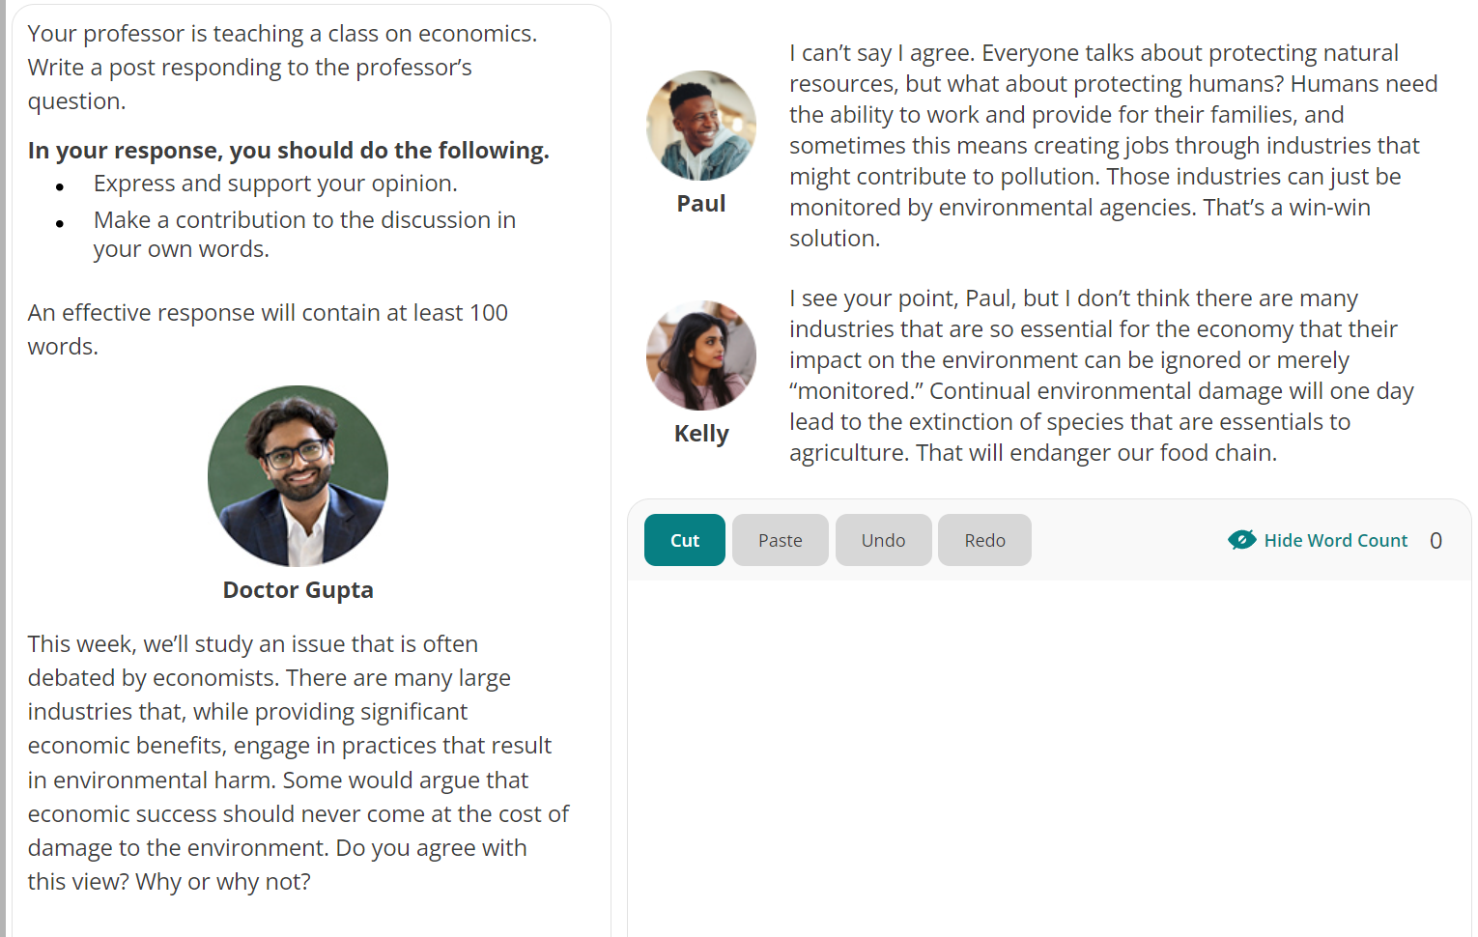26.**evaluation：**economic success at the cost of damage

Respond:

From my perspective, encouraging the development of economy at the cost of environment should never be a favorable strategy, as it might lead to unpredictable catastrophe to both human and ecosystem.

To be more specific, with the advancement of human society, we have deprived excessive sources from the nature, causing profound impact to the planet. For example, the climate change, driven primarily by human activities such as the combustion of fossil fuels and the extravagant use of vehicles, has caused profound consequences, encompassing increasing the global temperature, rising sea-level and deteriorating ecosystem health.

Admittedly, we need financial development to guarantee the welfare and livelihood of people, but there are more astute approaches we can implement to minimize the contamination we produce to environment. With the popularity of modern eco-friendly energy, such as solar and wind energy, companies can guarantee their manufacture while eliminating the emission of pollutant.

Only through consistent cooperation and thorough strategies can we alleviate climate change and pave the way to a more sustainable future.

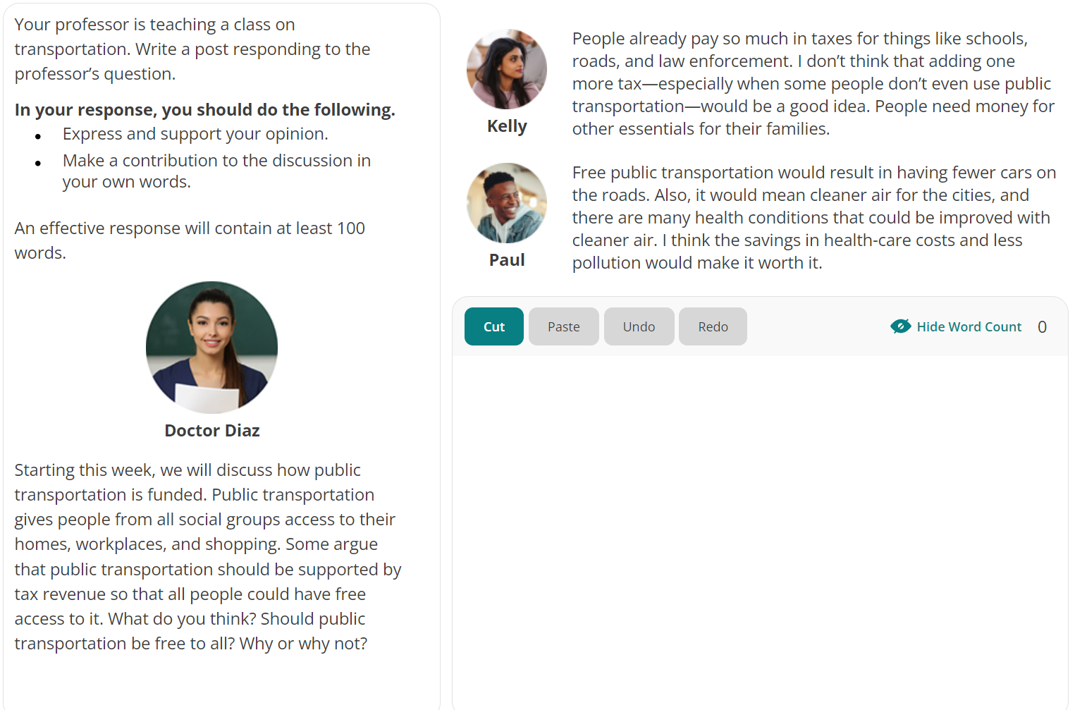27.evaluation: whether should public transportation be free

Respond:

Not be a favorable choice, environmental problems

1.agree with Paul, not only decrease the usage of private transportation and boost public transportation, reduce combustion of fossil fuels and emission of contamination, which lead to profound consequences, such as……

2. with the tax revenue, alleviate the financial burden of governments, allocate more money to infrastructure to guarantee the welfare of residents

28.**opinion:** the biggest mistake of buying tech products

Respond:

the most gigantic mistake—impulse buying without sufficient consideration, purchasing products not match their authentic requirement, lack of research, just pursue the prevailing trend without comprehensive research, resulting in dissatisfaction and regret

besides, ignore future compatibility. Another common mistake is not considering the longevity of the product in terms of software updates and compatibility with future technologies. Technology evolves rapidly, and some devices might become obsolete faster than others. Ignoring the future compatibility of the product can lead to a shorter lifespan

存在问题：  
1. a，an 的使用问题没有注意到

2. 时态问题，经常忘记加s 或者ed

思路：

1.comparison要使没有思路可以说一个的好处然后另一个的不好

2. 可以适当进行让步admittedly， but…， 或者同意一个同学的观点 再additionally

3.实在没话说就for example